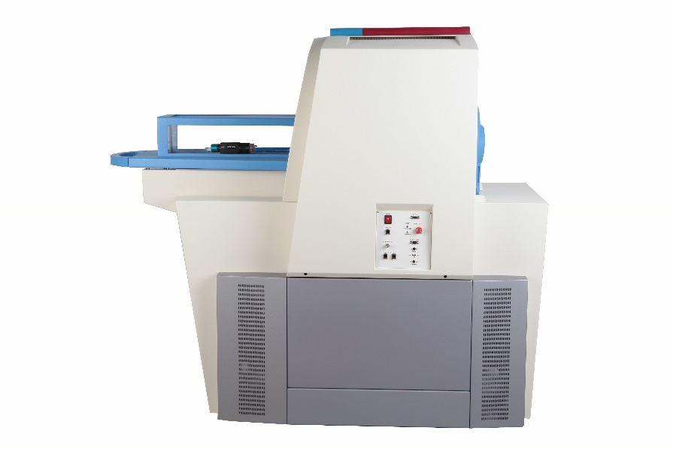

SuperArgus PET/CT
Unique technologies enabling advanced applications in PET/CT
PRODUCT SPECIFICATION

Model | Argus Compact | SuperArgus PET/CT 2r | SuperArgus PET/CT 4r | SuperArgus PET/CT 6r | SuperArgus PET/CT 2R | SuperArgus PET/CT 4R | SuperArgus PET/CT 6R | SuperArgus PET/CT 4P | SuperArgus PET/CT 6P
Animals | Mice only | Mice, rats and marmosets | Mice, rats and marmosets | Mice, rats and marmosets | Mice, rats, marmoset, rabbits (3 kg) | Mice, rats, marmoset, rabbits (3 kg) | Mice, rats, marmoset, rabbits (3 kg) | Non-human primates; canine; porcine, murine (10 kg) | Non-human primates; canine; porcine, murine (10kg)
Dynamic AFOV | 100 mm | 220 mm | 220 mm | 220 mm | 350 mm | 350 mm | 350 mm | 650 mm | 650 mm
Static AFOV | 100 mm | 50 mm | 100 mm | 150 mm | 50 mm | 100 mm | 151 mm | 100 mm | 150 mm
TFOV | 50 mm | 80 mm | 80 mm | 80 mm | 120 mm | 120 mm | 120 mm | 210 mm | 210 mm
Bore size | 55 mm | 90 mm | 90 mm | 90 mm | 160 mm | 160 mm | 160 mm | 260 mm | 260 mm
Detectors | 32 | 28 | 56 | 84 | 48 | 96 | 144 | 128 | 192
DOI crystals | 10816 | 9464 | 18928 | 28392 | 16224 | 32448 | 48672 | 43264 | 64896
